Task 2 – Weather App

Student Details
- Name: Karanam Ranjitha
- Domain: Frontend Development
- Internship: InternSpark

Objective
To design and develop a responsive frontend web application using HTML, CSS, Bootstrap, and JavaScript as part of the InternSpark internship program.

Technologies Used
- HTML5
- CSS3
- Bootstrap 5
- JavaScript
- GitHub

Features
- Real-Time Weather Data
- API Integration
- Temperature Display
- Humidity & Wind Speed
- Search Functionality
- Responsive Design

Screenshots

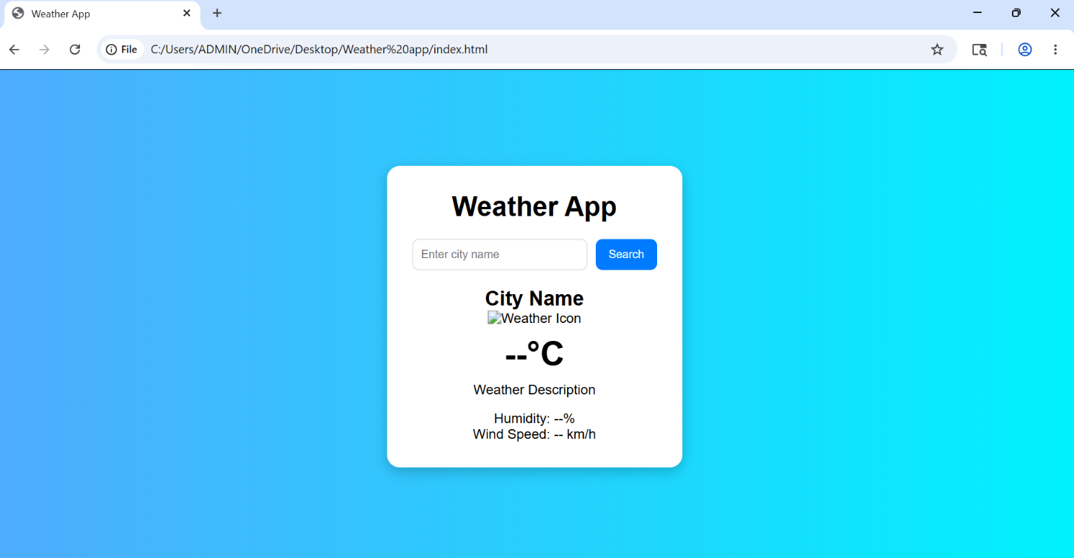

- 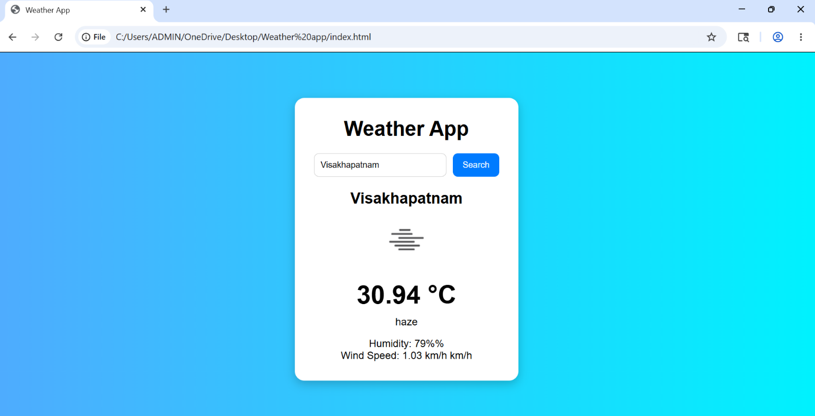

Code Snippets
Smooth Scroll CSS html{ scroll-behavior: smooth; }
Bootstrap Navbar
GitHub Repository Link
https://github.com/RanjithaKaranam/Weather-App-Project
Live Website Link
https://ranjithakaranam.github.io/Weather-App-Project/

Conclusion
This project helped me improve my frontend development skills, understand responsive web design concepts, and gain practical experience in building and deploying modern web applications using GitHub Pages.

